# Assignment Description

You are in charge of handing out the winnings for the lottery.  Write a program that gets the jackpot total and how many winners there are from the user.  Divide the jackpot amongst the winners, making sure the first winner gets 2x what everyone else gets. Sample output is shown below (user input is in bold). Don't forget to add inline comments to your code.

# GitHub URL (optional)

# Readme Documentation

Input Information: Input the number of lottery winners and the total jackpot

Output Information: Output the winning amount for the first winner and all other winners

# Flowchart Screen Shots (optional)

Screen shot(s) here

# UML and Use Case Diagrams (optional)

Screen shot(s) here

# Source Code of All files (.h, .cpp)

/* Program name: Dividing Winnings

* Author: Wesley Hixon

* Date last updated: 6/6/2024

* Purpose: Divides lottery winnings given the number of winners and amount of money

*/

#include <iostream>

using namespace std;

int main()

{

// Declaring variables

int jackpot, num_winners;

// Getting jackpot amount and number of winners

cout << "Enter the jackpot amount: ";

cin >> jackpot;

cout << "Enter the number of winners: ";

cin >> num_winners;

// Calculating the winning amount for first place and other winners

int other_winners_amount = jackpot / (num_winners + 1);

int first_winner_amount = other_winners_amount * 2;

// Printing the winning amount

cout << "The first winner gets: $" << first_winner_amount << "\n";

cout << "All the other winners get: $" << other_winners_amount << "\n";

}

# Three Use Case Screen Shots

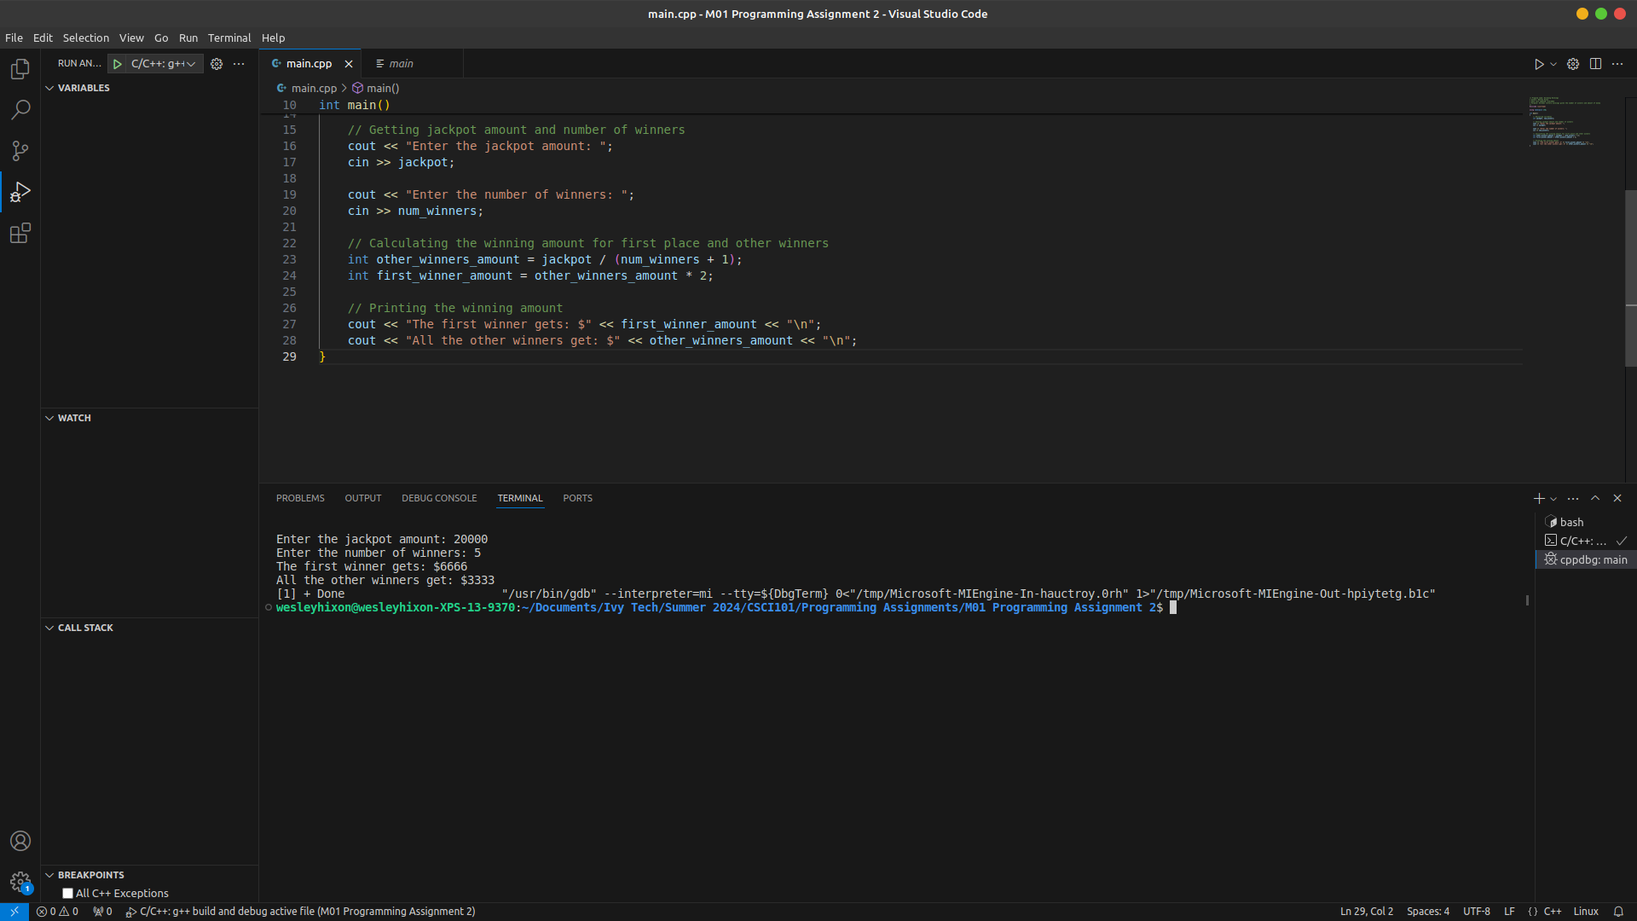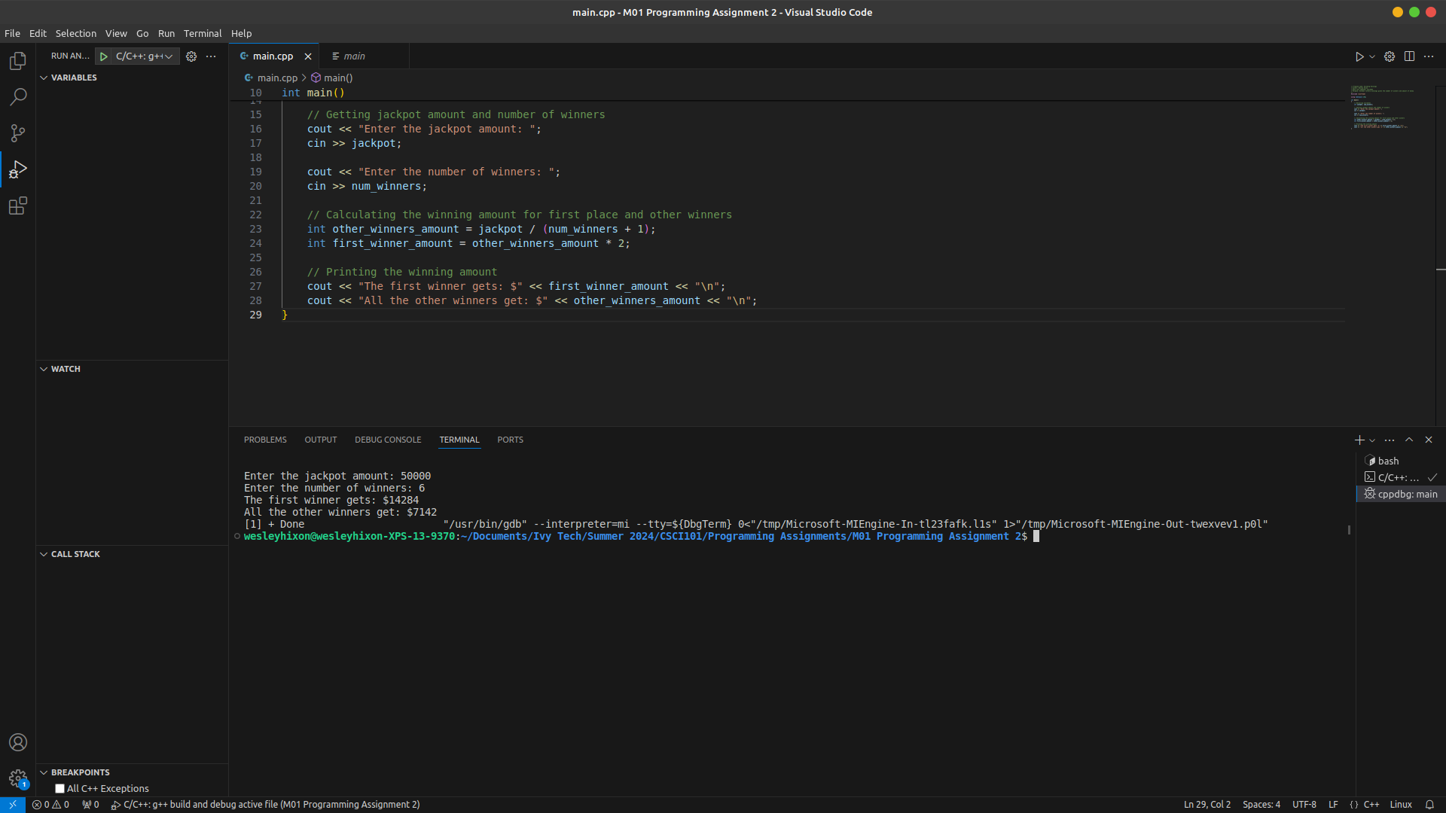

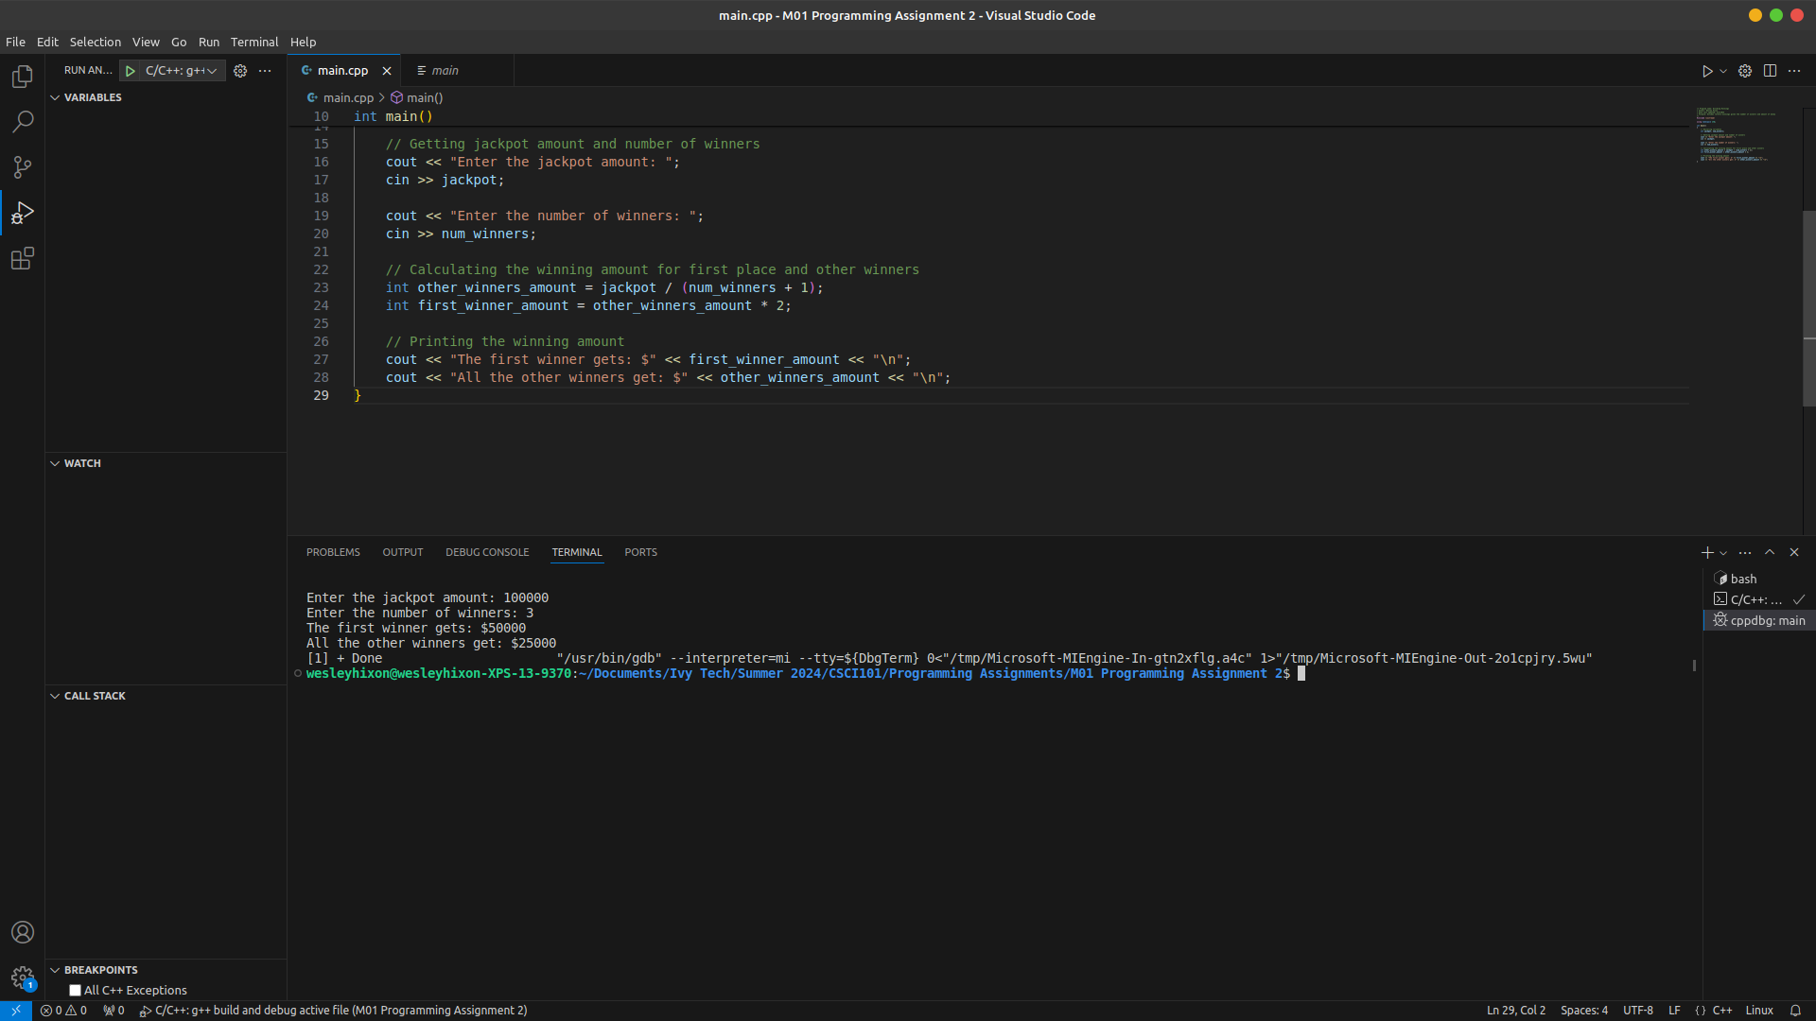

Please make sure all screen shots and text are clearly viewable for faster / easier grading!